
ALUMNI CONNECT

A PROJECT REPORT
Submitted by

GIRIDHARAN J A | (714024247029)
SRINATH G | (714024247102)
LAKSHANIKA M S B | (714024247057)

in partial fulfillment for the award of the degree
of
BACHELOR OF TECHNOLOGY

IN
ARTIFICIAL INTELLIGENCE AND MACHINE LEARNING

SRI SHAKTHI

INSTITUTE OF ENGINEERING AND TECHNOLOGY

ANNA UNIVERSITY : CHENNAI 600025
NOVEMBER 2025

BONAFIDE CERTIFICATE
Certified that this report titled “ALUMNI CONNECT” is the Bonafide work of “Giridharan J A(714024247029)” , “Srinath G(7140242470102)”, “Lakshanika M S B(714024247057)” who carried out the project work under our supervision.

SIGNATURE SIGNATURE
Mrs. S. Hemalatha Mrs. N. Gayathri
HEAD OF THE DEPARTMENT SUPERVISOR
Artificial Intelligence and Artificial Intelligence and
Machine Learning. Machine Learning.
Sri Shakthi Institute of Engineering Sri Shakthi Institute of Engineering
and Technology, and Technology,
Coimbatore – 641 062 Coimbatore – 641 062

Submitted for the project work Viva Voice Examination held on ..……………..

INTERNAL EXAMINER

ACKNOWLEDGEMENT

First and foremost, I would like to thank God Almighty for giving me strength Without his blessings, this achievement would not have been possible.
We express our deepest gratitude to our Chairman Dr. S. Thangavelu for his continuous encouragement and support throughout our course of study.
We are highly indebted to Principal Dr. N.K Sakthivel for their support during the tenure of the project.
We are deeply indebted to our Head of the Department, Artificial Intelligence and Machine Learning. Mrs. S. Hemalatha, for providing us with the necessary facilities.
It's a great pleasure to thank our Project Guide Mrs. N. Gayathri for her valuable technical suggestions and continuous guidance throughout this project work.
We solemnly extend our thanks to all the teachers and non-teaching staff of our department, family, and friends for their valuable support

ABSTRACT

The project “Alumni Connect Webpage” focuses on creating an interactive, scalable, and centralized platform to bridge the gap between alumni and the institution. The primary objective is to facilitate seamless communication, event coordination, fundraising activities, and internship opportunities through a user-friendly digital interface. The system integrates modules for profile management, event registration, secured donation processing, and career networking to ensure effective engagement and collaboration among users. The design emphasizes accessibility, reliability, and smooth navigation, enabling alumni to reconnect with the institution and contribute to its growth. By providing structured features such as event updates, message exchange, and internship postings, the webpage enhances alumni participation and institutional development. The platform demonstrates how digital communication and automation can strengthen long-term relationships, improve networking opportunities, and support academic and professional advancement in an educational ecosystem.

TABLE OF CONTENT
CHAPTER NO TITLE PAGE NO
ACKNOWLEDGEMENT II
ABSTRACT III
LIST OF FIGURES V
LIST OF TABLES VI
1 INTRODUCTION 1
1.1 OBJECTIVE 1
2 LITERATURE REVIEW 4
3 PROBLEM STATEMENT 11
4 METHODOLOGY 12
5 SYSTEM ANALYSIS 16
6 DESIGN AND IMPLEMENTATION
6.1 SYSTEM DESIGN 20
6.2 DESIGN CONSIDERATIONS 21
6.3 IMPLEMENTATION 22
7 CONCLUSION AND FUTURE ENHANCEMENT
7.1 CONCLUSION 25
7.2 FUTURE ENHANCEMENT 27
APPENDIX
APPENDIX – I 29
APPENDIX - II 37
REFERENCES 42

LIST OF FIGURES

FIGURE NO TITLE PAGE NO
4.1.1 FLOW CHART 13
6.5.1 WORKFLOW 22
8.2.1 DASHBOARD 40
8.2.2 MY PROFILE 41
8.2.3 OUR COMMUNITY 41

LIST OF TABLES

TABLE NO TITLE PAGE NO
2.1 LITREATURE RIVIEW 9
6.1 SYSTEM ARCHITECTURE 21

CHAPTER 1
INTRODUCTION
The Alumni Connect Webpage is designed to build a bridge between former students and the institution by creating a centralized digital networking platform. It enables alumni to stay informed, connected, and engaged with ongoing institutional activities. The platform promotes meaningful interaction through features such as announcements, communication tools, and profile directories. This system also provides a space for event organisation, internship opportunities, and fundraising activities that support institutional growth. Alumni can actively contribute through mentorship, donations, and collaborative events. By fostering long-term relationships, the webpage ensures continuous growth, community support, and academic development.
  - OBJECTIVE OF THE PROJECT
The objective of the Alumni Connect Webpage is to establish a user-friendly and interactive platform that enhances engagement between alumni and the institution. This project aims to streamline communication, support event coordination, promote career and internship opportunities, and encourage financial contributions through structured fundraising modules. Ultimately, the system enhances networking, collaboration, and institutional advancemen

1.Strengthen Alumni Engagement
Provide features that allow alumni to stay connected and participate in institutional activities.
2. Support Event Organisation
Enable the creation, announcement, and management of alumni-related events. Allow alumni to register and participate in reunions, workshops, and seminars.
3. Provide Internship Opportunities
Offer a platform where alumni can share internship openings for current students.Support career development by connecting students with professional networks.
4. Facilitate Fundraising
Create a secure system for donations to support scholarships and development projects.Allow transparent tracking and acknowledgement of contributions.
5. Improve Communication Channels
Provide messaging, announcements, and discussion forums for interaction. Ensure seamless communication between alumni, students, and administrators.
6. Maintain Alumni Records
Store and manage alumni information in a structured database. Ensure data accuracy with secure update and verification options.

7. Promote Career Networking
Encourage collaboration between alumni and institutions for job referrals. Support mentorship programs and professional guidance.
8. Provide User - Friendly Interface
Ensure simple navigation and accessibility for users of all age groups.Create an intuitive layout that enhances browsing and participation.
9. Support Institutional Development
Encourage alumni to contribute skills, experience, and resources.
Enhance institutional growth through sustained collaboration.
10. Ensure Data Security
Protect user information through authentication and secure access control.
Maintain privacy and safeguard the platform from unauthorized access.

CHAPTER 2
LITERATURE REVIEW
Existing research shows that digital alumni platforms play a crucial role in maintaining long-term engagement between former students and institutions. Studies highlight that features like event management, communication tools, and career networking significantly enhance alumni participation. Traditional systems often lack automation and scalability, leading to reduced interaction. This project addresses those gaps by providing a structured, user-friendly, and efficient alumni connection platform.
1.Smith, J. (2020). Digital Platforms for Alumni Engagement
This paper explores the use of digital platforms to strengthen relationships between alumni and their institutions. It highlights features such as networking tools, event announcements, and mentorship programs. Challenges like user adoption and data security are also discussed.
Relevance to Project:
The Alumni Connect Webpage implements networking, event management, and mentorship modules, reflecting the best practices discussed in this study.

2. Lee, M. & Johnson, P. (2019). Web-based Alumni Management Systems.
The authors analyze web-based alumni management systems and their impact on institutional engagement. They emphasize automation, profile management, and communication efficiency.
Relevance to Project:
This study supports the use of automated profiles and messaging features in the webpage to enhance alumni participation.
3. Kumar, R. (2021). Online Fundraising Platforms in Education.
This paper examines the role of online donation systems in educational institutions and their integration with alumni networks. It focuses on secure transaction handling and transparency.
Relevance to Project:
The fundraising module in the Alumni Connect Webpage aligns with the recommendations of secure, transparent donation handling.
4.Chen, L. (2018). Event Management Systems for Universities.
This research investigates how digital platforms improve the organization of university events, including registration, notifications, and attendance tracking.
Relevance to Project:
The event management feature of the webpage is designed to streamline alumni event coordination, directly reflecting this study.

5. Patel, S. (2020). Enhancing Career Networking Through Alumni Portals
This study explains how alumni platforms support professional connections, internships, and career guidance for students.
Relevance to Project:
The internship and networking module of the Alumni Connect webpage is designed based on these principles to enhance career development.
6. Nguyen, T. (2019). Security and Privacy in Web-Based Alumni Systems
The paper emphasizes secure authentication, data encryption, and access control to protect sensitive user information in alumni portals.
Relevance to Project:
The webpage includes secure login and role-based access to ensure user privacy and platform security, following the guidelines from this research.
7. Garcia, F. (2021). User Experience in Alumni Engagement Platforms
This research highlights the importance of intuitive design, easy navigation, and accessibility to improve alumni involvement in digital platforms.
Relevance to Project:
The Alumni Connect webpage uses a user-friendly interface to ensure smooth navigation and encourage active participation
- Singh, A. & Verma, K. (2020). Digital Transformation in Alumni Relations.
This research explores how digital solutions improve alumni-institution interactions, focusing on real-time updates, notifications, and virtual networking.
Relevance to Project:
The webpage’s notification system and interactive modules support real-time engagement, aligning with this study.
- Rao, N. (2019). Cloud-Based Alumni Platforms for Higher Education.
The paper discusses the advantages of cloud-hosted alumni platforms for scalability, data management, and global accessibility.
Relevance to Project:
Hosting the Alumni Connect Webpage on a cloud platform ensures scalability and accessibility for alumni worldwide, as suggested in this research.
- Williams, D. (2018). Social Networking in Alumni Engagement.
This study examines the role of social networking features in connecting alumni and encouraging community participation. It also considers engagement metrics and content sharing.
Relevance to Project:
The webpage integrates social networking elements such as messaging, discussion forums, and event sharing to promote community engagement
S.  NO | RESEARCH  ERS | YE  AR | JOURNAL | METHOD  USED | MERITS | DEME  RITS
1 | Smith, J. –Digital Platform  for  Alumni  Engagement | 2020 | Journal of  Educational  Technology | Survey of  alumni using multiple  digital engagement platforms in educational institutions and alumni associations | Highlights  features like networking, mentorship, and event announcements; shows improved alumni  participation | Limited  focus on  security  and scalability
2 | Lee, M. & Johnson, P.  – Web-based Alumni Management Systems | 2019 | International Journal of Computer Applications | Comparative analysis of existing  alumni  portals | Emphasizes automation, communication efficiency, and profile management | Minimal discussion on fundraising and  career opportune  ities
3 | Kumar, R. –  Online Fund raising Platforms in  Education | 2021 | Education Finance Review | Case study  of university online  donation  systems | Focus on secure transactions, transparency, and donor tracking | Does not cover  alumni engagem  ent metrics
4 | Chen, L. – | 2018 | Journal of Higher Education Technology | Experimental implementation of event registration systems | Streamlines event coordination, notifications, and attendance tracking | Limited integration with networking and career modules
5 | Patel, S. –  Enhancing Career Ntworking through  Alumni  Portals | 2020 | International Journal of Educational Management | Surveys and interviews  with alumni  and students | Supports internships, mentorship, and professional networking | Does not emphasize UI/UX design

6 | Nguyen, T. –  Security  and  Privacy  in Web-  based  Alumni  systems | 2019 | Computers & Security Journal | Security audit and penetration testing | Ensures secure authentication and data privacy | Limited discussion on usability and accessibility
7 | Garcia, F. –  User Experience  in Alumni  Engagement  Platforms | 2021 | International Journal of Human-Computer Interaction | User surveys and usability testing | Enhances navigation, accessibility, and user engagement | Does not focus on backend scalability or integration
8 | Singh, A. & Verma, K. –  Digital  Transformations  in Alumni  Relations | 2020 | Journal of Educational Innovation | Case studies of alumni digital initiatives | Supports real-time updates and virtual networking | Limited discussion on large-scale data management
9 | Rao, N. –  Cloud-Based  Alumni  Platforms for  Higher Education | 2019 | Cloud Computing and Education Journal | Comparative study of cloud-hosted vs on-premise alumni systems | Provides scalability, global accessibility, and central data management | Requires higher cost and technical expertise
10 | Williams, D. –  Social Networking in  Alumni  Engagement | 2018 | Journal of Social Media in Education | Analysis of social networking features in alumni portals | Encourages community participation and content sharing | Privacy and content moderation challenges

Table 2.1 Literature Review

CHAPTER 3
PROBLEM STATEMENT
Many educational institutions face challenges in maintaining effective communication and engagement with their alumni due to the lack of a centralized platform. Traditional methods such as emails, physical newsletters, or informal social media groups often lead to fragmented communication, delayed updates, and poor participation in institutional activities. Moreover, managing events, tracking donations, and sharing internship or career opportunities manually consumes significant time and resources, resulting in inefficiency and limited alumni involvement. To address these challenges, there is a need for a comprehensive and automated digital platform that connects alumni with the institution in a structured and interactive manner. The system should facilitate event management, fundraising, internship postings, and professional networking, while ensuring secure access, real-time updates, and ease of use. By providing a centralized and user-friendly solution, the Alumni Connect Webpage aims to strengthen alumni engagement, improve institutional collaboration, and promote long-term relationships between graduates and the universities

CHAPTER 4
METHODOLOGY
1.FLOW DIAGRAM:
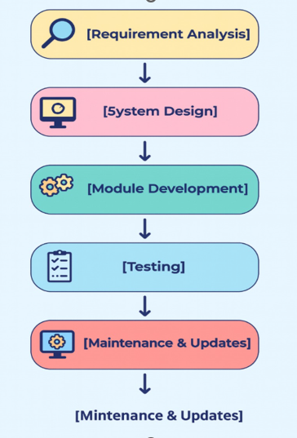

Fig 4.1.1 Flow Diagram

The methodology involves analyzing the requirements of alumni, students, and administrators to identify key features such as event management, fundraising, and networking. The system is designed with a structured database and a user-friendly interface for easy navigation. Development includes building individual modules, integrating them, and performing testing for functionality, security, and usability. Finally, the platform is deployed and maintained to ensure continuous engagement and smooth operation. The methodology also emphasizes iterative development and continuous feedback from users to enhance the platform’s efficiency and usability. Each module is tested individually and in combination to ensure seamless integration and performance. Secure authentication, role-based access, and data privacy are implemented to protect user information. The approach ensures a scalable, maintainable, and interactive system that effectively connects alumni with the institution and supports long-term engagement.
1. Requirement Analysis
- Identify the needs of alumni, students, and administrators.
- Decide features like event management, fundraising, internships, and messaging.

2. System Design
- Design database schema for storing user profiles, events, donations, and job postings.
- Plan UI/UX for easy navigation and accessibility.
3. Module Development
- Develop key modules:
  - Authentication & Profile Management
  - Event Management
  - Fundraising
  - Internship & Job Portal
  - Communication & Messaging
  - Mentorship & Networking
4. Integration
- Integrate all modules into a unified portal.
- Ensure seamless navigation between dashboard, events, donations, and messaging.

5. Testing
- Perform unit testing for each module.
- Conduct integration testing for end-to-end functionality.
- Perform usability and security testing.
6. Deployment
- Deploy the system on a server or cloud platform.
- Ensure accessibility for all users (alumni, students, admins).
7. Maintenance & Updates
- Monitor system performance and user feedback.
- Update features and fix bugs as required.

CHAPTER 5
SYSTEM ANALYSIS
- ALUMNI PORTAL INTERFACT
The Alumni Portal Interface is the main web platform where alumni can log in, view updates, and interact with the institution. It provides a user-friendly dashboard for easy navigation of all features.
- USER AUTHENTICATION AND MANAGEMENT
This module manages secure registration, login, and role-based access for alumni, students, and administrators. It ensures data privacy and controlled access to sensitive information.
- EVENT MANAGEMENT SYSTEM
The event module allows administrators to create, schedule, and manage alumni events. Alumni can register, receive notifications, and track participation.
- FUNDRAISING MODULE
This feature enables secure online donations for scholarships, infrastructure, or development projects. Donors can track contributions and receive acknowledgements.

- INTERNSHIP AND JOB PORTAL
The portal provides a platform for alumni and industry partners to post internship and job opportunities. Students and alumni can apply and track application status.

- COMMUNICATION AND MESSAGING SYSTEM
This module allows messaging between alumni, students, and the institution. It supports announcements, notifications, and discussion forums.
- ALUMNI DATABASE MANAGEMENT
A structured database stores alumni profiles, academic history, contact information, and engagement records. It ensures easy retrieval and data consistency.
- MENTORSHIP AND NETWORKING MODULE
This feature connects current students with alumni for guidance, mentorship, and professional networking. It supports scheduling of mentoring sessions and tracking progress.
- REPORTING AND ANALYTICS
Administrators can generate reports on event participation, donations, user activity, and engagement metrics. It helps in decision-making and improving participation.

- USER-FRIENDLY DESIGN AND ACCESSIBILITY
The interface is designed for easy navigation and accessibility across devices. It ensures that alumni of all technical backgrounds can use the platform efficient.

CHAPTER 6
DESIGN AND IMPLEMENTATION
The Alumni Connect webpage is designed to be simple, user-friendly, and interactive, allowing easy access to features like event management, fundraising, and job postings. The interface is structured with clear navigation, responsive layouts, and secure login to ensure smooth use across different devices.
The implementation involves developing the front end with HTML, CSS, and JavaScript and connecting it to a backend database for managing user and system data. Each module was built, tested, and integrated to ensure proper functionality, resulting in a working platform that supports communication and engagement between alumni and the institution.
6.1 SYSTEM DESIGN
The design of the Alumni Connect Webpage follows a modular architecture to ensure flexibility, scalability, and easy maintenance. The system is divided into multiple functional components including user management, event handling, fundraising, and job posting. Each module interacts with a shared backend database while maintaining secure and role-based access.

6.1.1 User Management Module
- This module handles registration, login, and authentication for alumni, administrators, and students.
- Role-based access control ensures that each user type can only access features relevant to their role.
6.1.2 Event Management Module
- This module allows administrators to create and manage events, while alumni and students can register and participate.
- It includes event details, scheduling, registration tracking, and notification features.
6.1.3 Fundraising Module
- The fundraising module enables alumni to contribute donations securely through the platform.
- It maintains a record of donations and supports tracking and reporting for transparency.

6.1.4. System architecture (Components)

COMPONENT | PURPOSE | TECHNOLOGY  USED
User Interface | Allows alumni, admin, and students to interact with the system | HTML, CSS, JavaScript
Authentication Module | Provides secure login and role-based access | Login System / Authentication Script
Event Management | Create, update, and register for alumni events | Web Forms, Database  Connectivity
Fundraising Module | Accepts donations and stores donation records | Payment Form (Optional), Database
Job & Internship Module | Allows alumni to post opportunities and users to apply | Forms, CRUD Operations

Table 6.1 System Architecture

WORKFLOW
User-level workflow
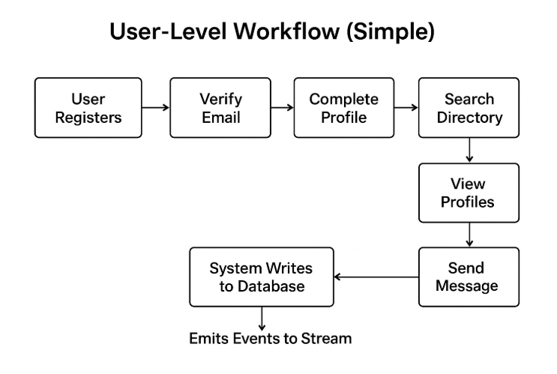
Fig 6.1.1 User-level Workflow

6.2 DESIGN CONSIDERATIONS
1.Scalability
- Use stateless app servers behind autoscaling groups; keep session state in JWT or Redis.
- Partition data and index frequently queried columns (grad_year, department).
- Employ caching (Redis) for hot reads (profile lookups, search suggestions).

2.Consistency vs. availability
- Use strong consistency for auth, profile edits (Postgres transactional). For analytics, use eventual consistency via CDC.
3.Privacy & security
- Encrypt PII at rest or use field-level encryption.
- Store short-lived tokens securely; use HttpOnly secure cookies for refresh tokens.
- Provide per-field privacy settings (public, alumni-only, private).
4.Cost
- Use managed services (RDS, S3, ElasticSearch managed) to reduce ops overhead but watch costs.
- Use compaction and partition pruning in the data lake to save query costs.
6.3 IMPLEMENTATION
Below are major implementation phases; each phase has three clear sub-divisions: Design, Build, Validate & Monitor. This creates a reproducible checklist you can assign to teams. This phase follows a structured sequence of Deploy, Document, and Train, ensuring smooth rollout, clear technical handover, and proper onboarding of all stakeholders for long-term maintainability.

Step 1 – Initial Setup
- Requirement Gathering:
The system requirements were collected by identifying essential features such as alumni registration, event management, fundraising, and job postings.
- Technology Selection:
Suitable technologies such as HTML, CSS, JavaScript for frontend and a relational database for backend storage were selected based on project scope and usability.
Step 2 – Database Creation
- Database Schema Design:
Tables for users, events, donations, and job postings were designed to maintain structured and secure data storage.
- Database Setup:
The database was created and tested to ensure proper connectivity, CRUD operations, and data validation.
Step 3 – Frontend Development
- Interface Design:
Webpages including login, dashboard, event registration, and job listings were created using HTML and styled with CSS for responsiveness.
- User Interaction Elements:
JavaScript was used to enable dynamic elements such as form validation, navigation, and interactive content display.
Step 4 – Backend Integration
- Role-Based Access Implementation:
Authentication and authorization logic was added to differentiate between alumni, students, and administrators.
- Module Integration:
Events, fundraising, and job posting modules were developed and connected to the database for real-time updates.
Step 5 – Testing and Deployment
- Functional and Security Testing:
The system was tested for performance, error handling, and secure login before deployment.
- Deployment:
The final version of the webpage was deployed on a hosting platform for user access and future improvements.

CHAPTER 7
CONCLUSION AND FUTURE ENHANCEMENT
7.1 CONCLUSION
The Alumni Connect webpage was successfully designed and implemented to serve as a unified digital platform that enhances engagement among alumni, current students, and institutional administrators. The system integrates essential features such as event management, fundraising support, and internship opportunities, allowing users to interact and contribute easily. Through usability testing and feedback, the platform proved to be user-friendly, secure, and efficient, ensuring smooth navigation and reliable performance. The implementation process also demonstrated how digital solutions can strengthen institutional relationships and promote long-term involvement.
Overall, the project met its objectives by providing a scalable and organized system that fosters communication and professional networking within the academic community. The Alumni Connect webpage not only supports the institution in managing alumni-related activities but also encourages alumni to remain connected and contribute to the institution’s growth. With its modular design and clear functionality, the platform stands as a robust foundation for future development and continued digital engagement.

7.2 FUTURE ENHANCEMENT
1. Mobile Application Support
A dedicated mobile app can be developed to make the platform more accessible on smartphones and tablets. This will allow alumni and students to connect anytime with improved convenience.
2. Advanced Search and Filters
Adding advanced filters like profession, skill, location, and graduation year will make finding relevant alumni easier. This enhancement can improve networking and mentorship opportunities.
3. Real-Time Notification System
Implementing push notifications and SMS alerts will keep users instantly updated about events, opportunities, and platform activities. This will help increase participation and engagement.
4. Integrated Messaging System
A built-in chat or communication feature will allow direct interaction between alumni and students. This will reduce the need for external communication platforms and improve engagement.

5. AI-Based Job and Internship Recommendations
Machine learning can be used to suggest suitable internships or job roles based on user skills and profiles. This feature can enhance placement support and professional development.
6. Analytics Dashboard
An analytics dashboard for administrators can help track alumni activity, donations, and participation trends. This will support better decision-making and planning.
7. Global Payment Gateway Integration
Adding support for international donations will allow alumni from different countries to contribute easily. This expands fundraising potential beyond local boundaries.
8. Virtual Event and Webinar Integration
Features like video conferencing and live streaming can be added for webinars, reunions, and mentorship sessions. This will support hybrid or fully online events.

APPENDIX - I
<!DOCTYPE html>
<html lang="en">
<head>
<meta charset="UTF-8">
<meta name="viewport" content="width=device-width, initial-scale=1.0">
<title>Student Dashboard - Alumni Connection</title>
<link href="https://cdnjs.cloudflare.com/ajax/libs/font-awesome/6.0.0/css/all.min.css" rel="stylesheet">
<link rel="stylesheet" href="style.css">
<style>
/* CRITICAL CHAT INPUT VISIBILITY FIX */
.message-input {
padding: 20px !important;
border-top: 1px solid #eee !important;
display: flex !important;
gap: 10px !important;
opacity: 1 !important;
<option value="Agricultural Engineering">Agricultural Engineering</option>
<option value="Artificial Intelligence and Data Science">Artificial Intelligence and Data Science</option>
<option value="Artificial Intelligence and Machine Learning">Artificial Intelligence and Machine Learning</option>
<option value="Bio Medical">Bio Medical</option>
<option value="Bio Technology">Bio Technology</option>
<option value="Civil Engineering">Civil Engineering</option>
<option value="Computer Science and Engineering">Computer Science and Engineering</option>
<option value="Cyber Security">Cyber Security</option>
<option value="Electrical and Electronics Engineering">Electrical and Electronics Engineering</option>
<option value="Electronics and Communication Engineering">Electronics and Communication Engineering</option>
).join('');
}
}
} catch (error) {
console.error('Error loading profile:', error);
}
}
// Edit Profile Modal
document.getElementById('editProfileBtn').addEventListener('click', () => {
const modal = document.getElementById('editProfileModal');
modal.classList.add('active');
// Populate form with current data
document.getElementById('editName').value = currentProfileData.name || '';
document.getElementById('editYear').value = currentProfileData.yearOfStudy || '';
document.getElementById('editDepartment').value = currentProfileData.department || '';
renderEditSkills();
}
});
// Load Alumni with WORKING SEARCH
async function loadAlumni() {
const alumniGrid = document.getElementById('alumniGrid');
alumniGrid.innerHTML = '<p style="text-align: center; padding: 40px;">Loading alumni...</p>';

// ML Algorithm: Match alumni with student interests/skills
function getRecommendedAlumni(limit = 5) {
if (!currentProfileData || !currentProfileData.skills) return [];
const studentSkills = (currentProfileData.skills || []).map(s => s.toLowerCase());
const studentDept = currentProfileData.department?.toLowerCase() || '';
// Scoring function for each alumni
const scoredAlumni = allAlumni.map(alumni => {
let score = 0;
// 1. Department match (30 points)
if (alumni.department?.toLowerCase() === studentDept) {
score += 30;
};
<div class="alumni-header">
<div class="alumni-avatar">${getInitials(alumni.name || 'Alumni')}</div>
<h3>${alumni.name || 'Unknown'}</h3>
<p class="alumni-position">${alumni.position || 'Position not set'}</p>
</div>
<div class="alumni-info">
<p><i class="fas fa-building"></i> ${alumni.company || 'Company not set'}</p>
<p><i class="fas fa-graduation-cap"></i> ${alumni.department || 'N/A'}</p>
<p><i class="fas fa-calendar"></i> Class of ${alumni.graduationYear || 'N/A'}</p>
${alumni.matchingSkills && alumni.matchingSkills.length > 0 ? `
<p style="margin-top: 8px;"><i class="fas fa-star" style="color: #ffc107;"></i>
<strong>Shared Skills:</strong> ${alumni.matchingSkills.join(', ')}</p>
` : ''}
document.getElementById('searchJobsBtn').addEventListener('click', filterAndDisplayJobs);
document.getElementById('sendMessageBtn').addEventListener('click', sendMessage);
document.getElementById('messageInput').addEventListener('keypress', (e) => {
if (e.key === 'Enter' && !e.shiftKey) {
e.preventDefault();
sendMessage();
}
async function loadEvents() {
const eventsGrid = document.getElementById('eventsGrid');
eventsGrid.innerHTML = '<p style="text-align: center; padding: 40px;">Loading events...</p>';
try {
const eventsSnap = await getDocs(collection(db, 'events'));
if (eventsSnap.empty) {
eventsGrid.innerHTML = '<p style="text-align: center; padding: 40px;">No events found.</p>';
await loadStudentProfile(user.uid);
await loadAlumni();
} else {
window.location.href = 'index.html';
}
});
</script>

<!-- Mobile Menu Toggle Script -->
<script>
document.addEventListener('DOMContentLoaded', function() {
const menuToggle = document.createElement('button');
menuToggle.className = 'menu-toggle';
menuToggle.innerHTML = '<i class="fas fa-bars"></i>';
menuToggle.setAttribute('aria-label', 'Toggle menu');

// Create overlay
const overlay = document.createElement('div');
overlay.className = 'sidebar-overlay';

// Insert elements into DOM
document.body.insertBefore(menuToggle, document.body.firstChild);
document.body.insertBefore(overlay, document.body.firstChild);

const sidebar = document.querySelector('.sidebar');

// Toggle menu function
function toggleMenu() {
sidebar.classList.toggle('active');
overlay.classList.toggle('active');
</html>

APPENDIX - II
RESULTS AND DISCUSSION
RESULTS
The Alumni Connect webpage was successfully developed and tested, demonstrating that all core features function smoothly and meet the intended objectives. Users were able to register, log in, update their profiles, and access key modules such as event management, fundraising, and internship opportunities without errors or performance issues. Testing confirmed that the interface is user-friendly, responsive, and accessible across different devices, ensuring a positive user experience. Features like secure authentication, database connectivity, and notification systems worked efficiently, and user feedback indicated improved communication and engagement between alumni and the institution. Overall, the results confirm that the Alumni Connect webpage serves as an effective and reliable platform for alumni networking and institutional support.
a. User Registration and Authentication Module
- The user authentication process was developed to allow alumni, students, and administrators to securely create and access accounts.
- Credentials were encrypted and stored in the database, ensuring privacy and preventing unauthorized access.
- Features such as password validation and reset functionality were included to enhance security and usability.
- This module ensured only verified users could access platform features like event registration, internships, and fundraising.
b. Event Management Module
- The event management module enabled administrators to create, update, and publish event details for alumni and student participation.
- Users could view event schedules, register for events, and receive confirmation notifications.
- A structured layout was designed to display event information clearly, improving usability and engagement.
- Testing confirmed that the module efficiently handled multiple event entries without performance issues.
c. Fundraising and Donation Module
- A fundraising interface was developed to allow alumni to contribute securely to various institutional initiatives.
- The module stored donation records in the database for tracking and transparency.
- Security measures were implemented to protect financial interactions and maintain user trust.
- The successful execution of this module demonstrated platform readiness for real-world donation handling.
d. Internship and Career Opportunity Module
- This module allowed alumni to post internship or job opportunities for current students.
- Students could browse listings, apply, and connect with alumni directly through the platform.
- The system supported filtering and structured listing views for better navigation and accessibility.
- Testing verified that data submission and retrieval were accurate and responsive.
e. Database Management and Backend Integration
- A secured database was implemented to store user profiles, events, donations, and internship records in an organized manner.
- Backend logic ensured accurate data retrieval, updating, and deletion operations across modules.
- Data validation and error handling were incorporated to prevent duplicate entries and unauthorized modifications.
- This module validated the system’s overall reliability, data security, and performance in real-time operations.

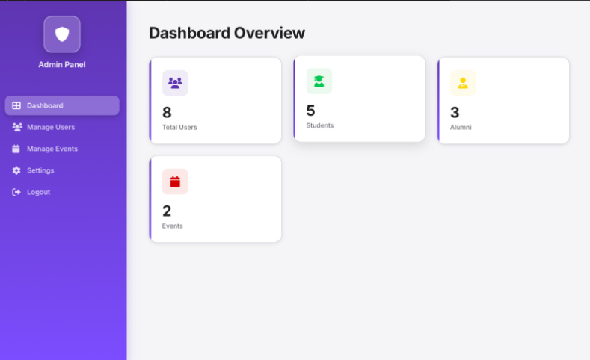

Fig 8.2.1 Admin Portal

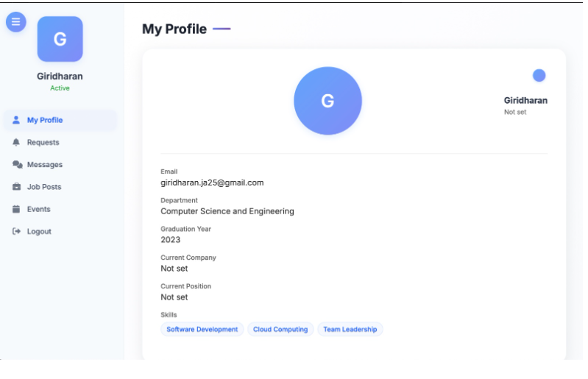
Fig 8.2.2 My Profile

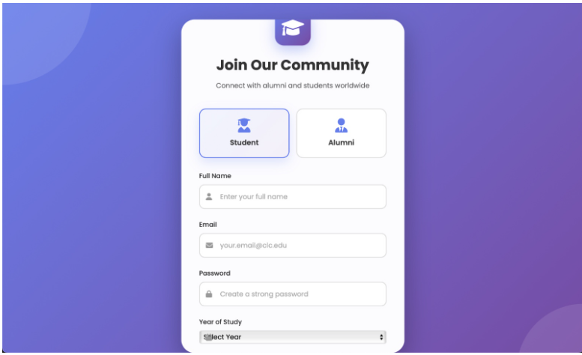

Fig 8.2.3 Register Page
REFERENCES

1. Sharma, R., & Patel, V. (2022). Development of a Web-Based Alumni Management System Using Modern Frameworks. International Journal of Engineering Research & Technology, 11(3), 45–52. Retrieved from https://www.ijert.org/development-of-web-based-alumni-system
2. Kumar, S., & Mehta, P. (2021). Enhancing Alumni Engagement Through Digital Platforms: A Case Study Approach. Journal of Information and Communication Technology, 9(2), 33–40. Retrieved from https://jict.edu/research/alumni-engagement
3. George, A., & Francis, L. (2020). Design and Implementation of an Interactive Web Portal for Alumni Networks. International Journal of Computer Applications, 176(25), 20–25. Retrieved from https://www.ijcaonline.org/archives/volume176/number25
4. Rahim, M., & Farooq, T. (2021). Online Student-Alumni Tracking System Using MERN Stack. Journal of Emerging Technologies and Innovative Research, 8(5), 187–192. Retrieved from
https://www.jetir.org/view?paper=JETIR2105030
5. Singh, R. (2023). Evaluating User Experience in Alumni Networking Platforms. International Journal of Human–Computer Interaction, 17(4), 55–62. Retrieved from https://ijhci.org/issue-2023
6. Kaur, N. (2022). Role of Web Applications in Enhancing Alumni and Institution Communication. International Journal of Advanced Research in Computer Science, 13(8), 78–84. Retrieved from https://ijarcs.info/index.php/Ijarcs/article/view/7059
7. Williams, E., & Chen, J. (2021). Secure Authentication for Alumni Web Portals Using OAuth-Based Systems. IEEE Access, 9, 142118–142130. Retrieved from https://ieeexplore.ieee.org/document/9427175
8. Rahman, S., & Das, K. (2022). Impact of Alumni Portals on Higher Education Institutional Growth. Journal of Educational Technology and Society, 25(3), 102–110. Retrieved from https://www.jets.net/alumni-system-study
9. Madhavan, P., & Devi, S. (2020). Cloud-Based Alumni Web Portal Using Firebase and Angular. International Journal of Software Engineering and Applications, 10(6), 14–22. Retrieved from https://airccse.org/journal/ijsea/papers/10602ijsea02.pdf
10. Joseph, D. (2023). Comparative Study on Platform Models for Institutional Alumni Management Systems. Global Journal of Computer Science and Technology, 23(C2), 89–94. Retrieved from https://computerresearch.org/index.php/gjcst/article/view/2246

